RDS Relational database Service

- Create MariaDB DB on EC2.
Overview of what I will do
- Launch an EC2 instance (choose AMI, instance type, key pair, security group).
- SSH to the instance.
- Install MariaDB (commands differ slightly by distro).
- Run the secure setup (mysql_secure_installation) and create DB/user.
- Configure network access securely (EC2 Security Group + bind-address + firewall).
STEP 1: OPEN ONE EC2
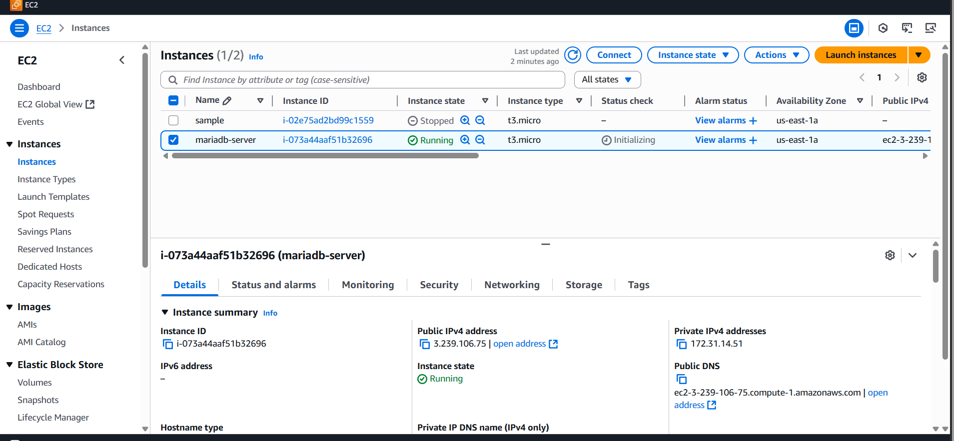
STEP 2:
SSH into the instance
From your local machine:
Step 2:
Install MariaDB
Begin Configuration :
sudo su -
yum -y install mariadb-server wget
systemctl enable mariadb
systemctl start mariadb
follow these steps to install
# update packages
sudo yum update -y
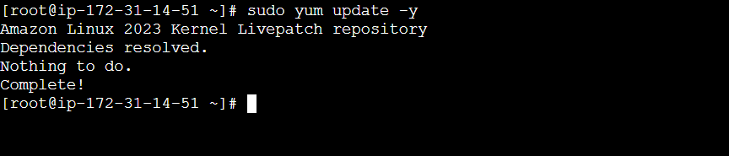
# install MariaDB server
sudo dnf install -y mariadb105-server (or) sudo yum install -y mariadb-server
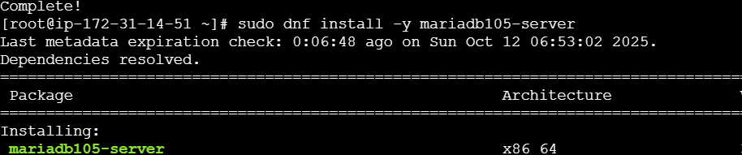
# start and Enable and start the service
sudo systemctl start mariadb
sudo systemctl enable mariadb
# check status
sudo systemctl status mariadb
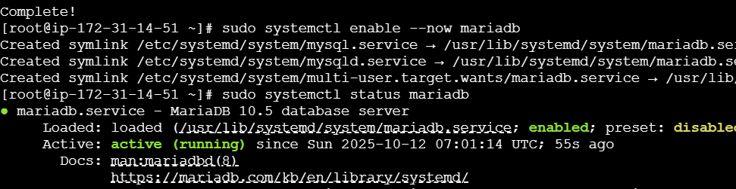

You can verify version:
mariadb --version
Step 4) Secure the installation
Run the interactive secure script:
sudo mysql_secure_installation
  - it will ask, please read the details, give your details, and carefully

  - Set a root password (or confirm the auth plugin)
  - Remove anonymous users
  - Disallow remote root login
  - Remove test database
  - Reload privilege tables

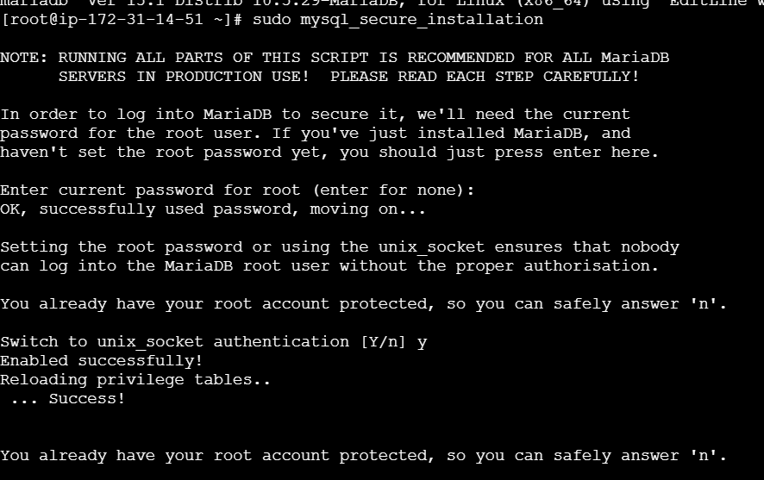
Step 5 : data base setup
Create a database and dedicate use
# login as root (no password on many installs; sudo runs as unix socket)
sudo mariadb
sudo lsof -I tcp:3306
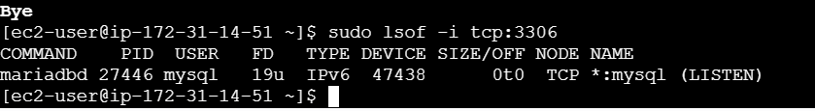

DBName=ec2db
DBPassword=admin123456
DBRootPassword=admin123456
DBUser=ec2dbuserEcho DBName = it show our username
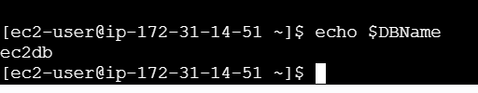
Database Setup on EC2 Instance:
===============================
echo "CREATE DATABASE ${DBName};" >> /tmp/db.setup
echo "CREATE USER '${DBUser}' IDENTIFIED BY '${DBPassword}';" >> /tmp/db.setup
echo "GRANT ALL PRIVILEGES ON *.* TO '${DBUser}'@'%';" >> /tmp/db.setup
echo "FLUSH PRIVILEGES;" >> /tmp/db.setup
mysqladmin -u root password "${DBRootPassword}"
mysql -u root --password="${DBRootPassword}" < /tmp/db.setup
rm /tmp/db.setup

echo "CREATE DATABASE ${DBName};" >> /tmp/db.setup
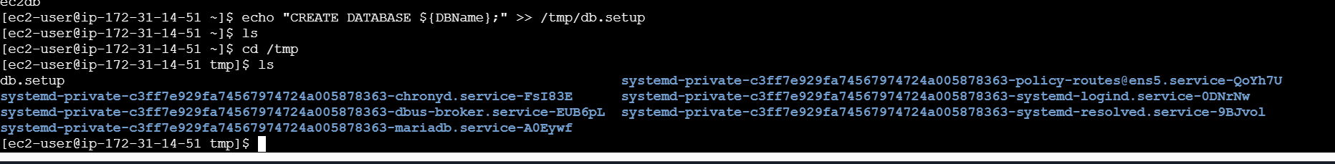
Cat db.setup
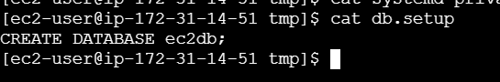
Show databases: it will be like that
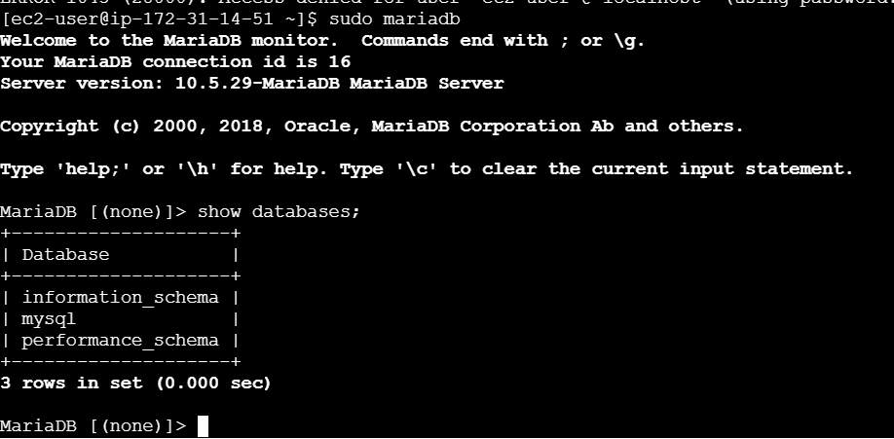
It wants to change the database “use mysql” use this command
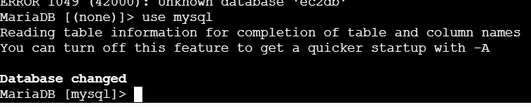

- Insert some dummy data.
CREATE DATABASE company_db => it will create name
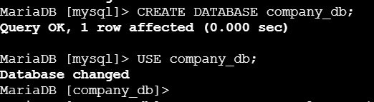
Let’s create a table named employees with realistic columns:
Explanation:
- emp_id → unique employee ID (auto increments)
- first_name / last_name → employee names
- department → department name
- salary → salary in rupees or dollars
- hire_date → date the employee joined

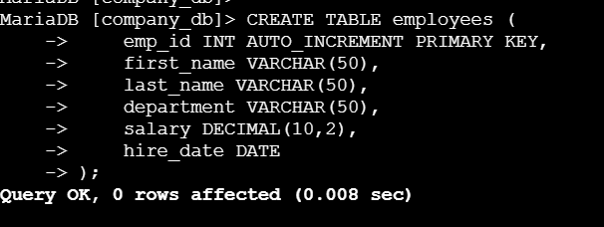
Insert dummy data
Now insert a few sample employee records:
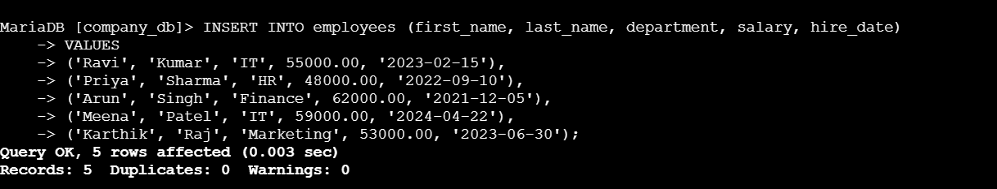
View the data
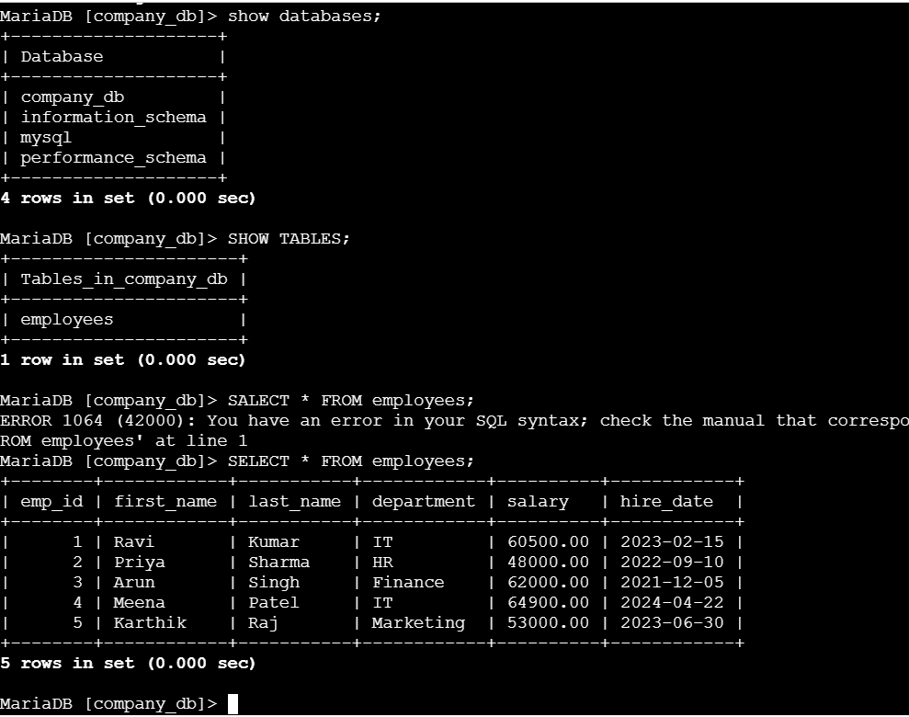
SELECT * FROM employees;
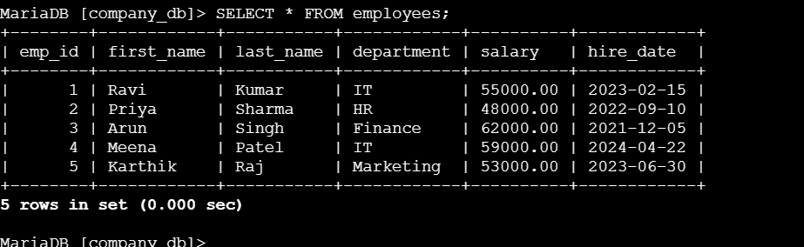
If you want specific depart ment you can give command like that
SELECT * FROM employees WHERE department = 'IT';
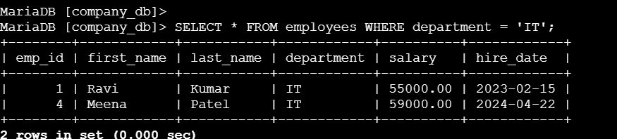
-- Find employees in IT department
SELECT * FROM employees WHERE department = 'IT';

-- Increase salary by 10% for IT department
UPDATE employees SET salary = salary * 1.10 WHERE department = 'IT';
We can see the difference
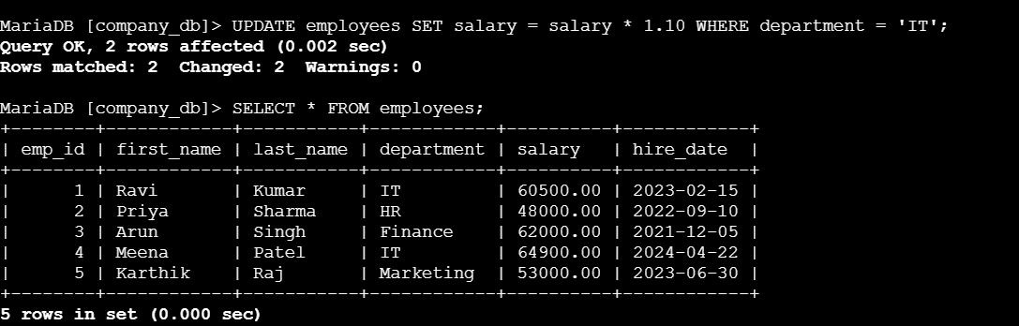
-- Find employees who joined after 2023
SELECT first_name, last_name, hire_date FROM employees WHERE hire_date > '2023-01-01';

-- Delete one employee (example)
DELETE FROM employees WHERE emp_id = 3;

- Take a backup of dummy data on EC2.
Take a backup (dump) of your database

🪄 Command if your root user works with sudo (no password)
sudo mysqldump company_db > /tmp/company_db.sql

Verify the backup file
Check file size:
ls -lh /tmp/company_db.sql

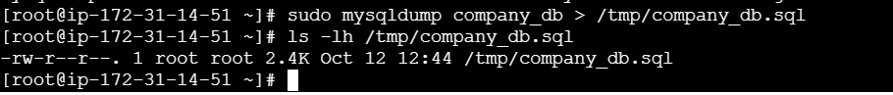
head /tmp/company_db.sql
That means your backup file is successfully created.
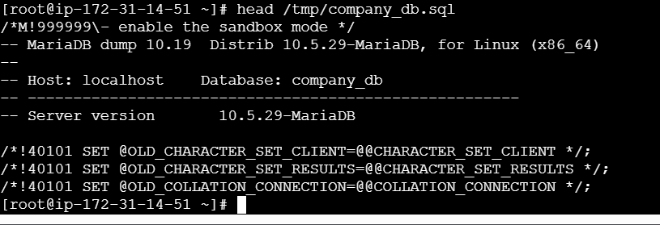
Summary — main backup command
If you just want to back up the data manually:
sudo mysqldump company_db > /tmp/company_db.sql
seeing our data
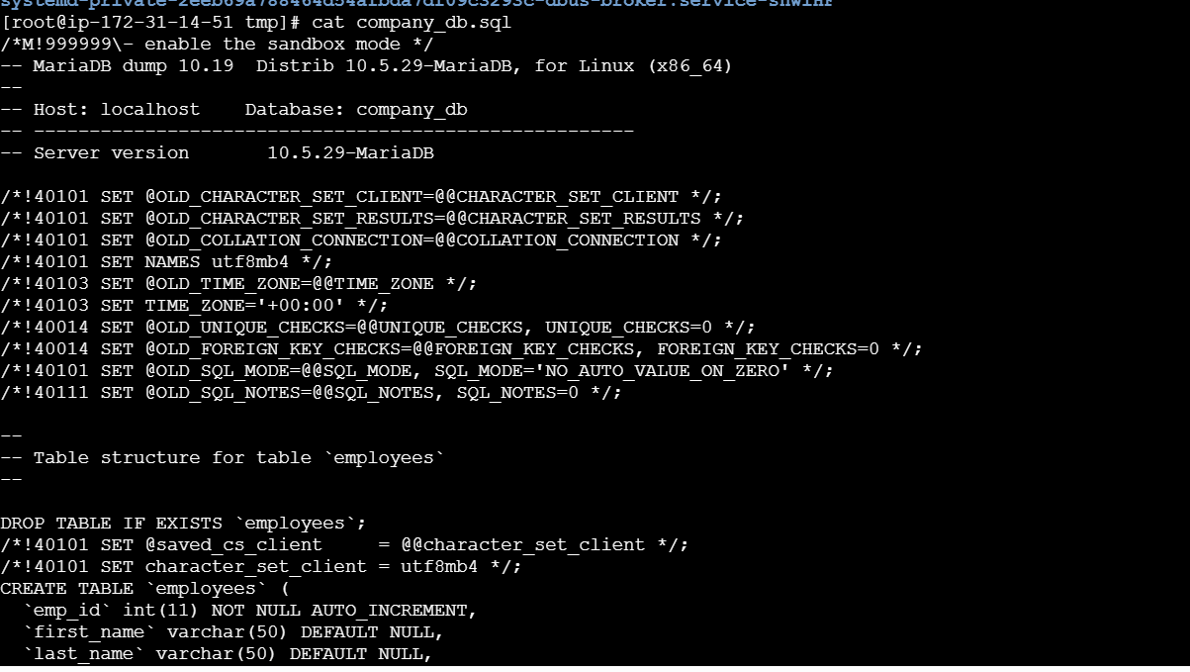

- Launch MariaDB RDS instance.
Launch RDS Database
- Click Databases → Create database.
- Choose Standard Create (for full control).
- Engine options: Select MariaDB.
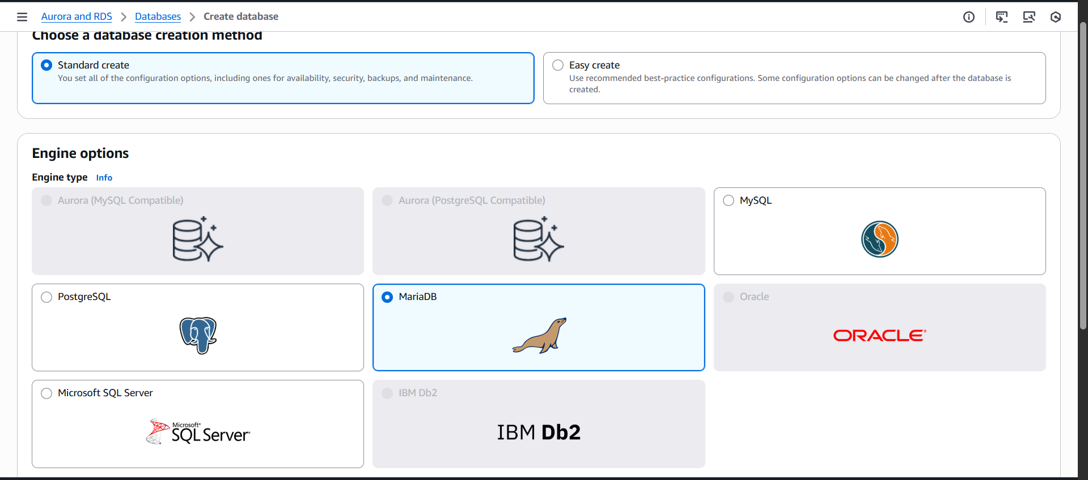
- Version: Choose latest stable (e.g., 10.11.x).
- Template:
  - Production → High availability options (Multi-AZ)
  - Dev/Test → Single AZ (cheaper)
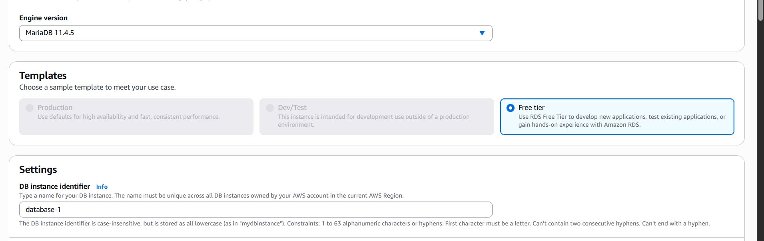
Step 3: Configure DB instance
- DB instance identifier: mariadb-instance1 (example)
- Master username: admin
- Master password: set a strong password → confirm it Bharathi
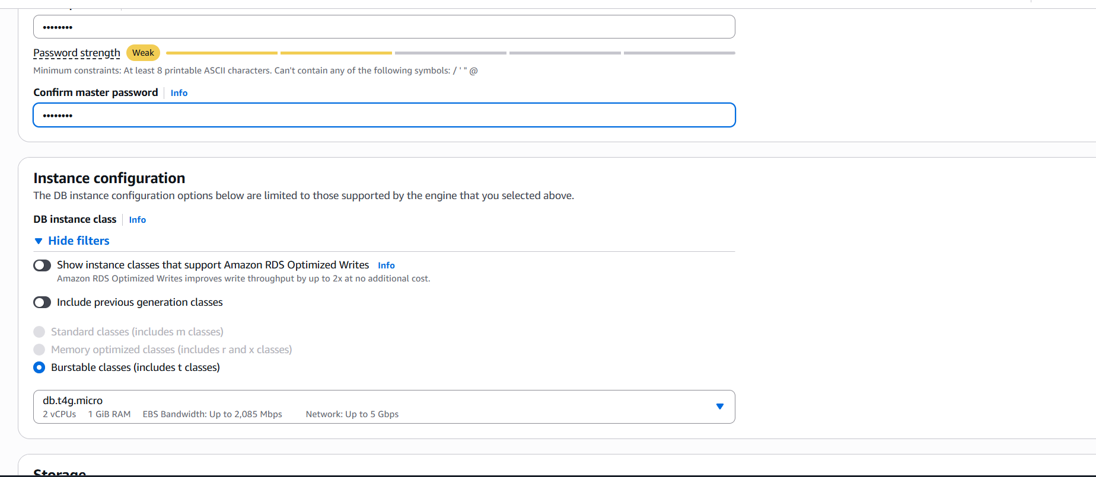
Choose the default one
- DB instance size:
  - For testing: db.t3.micro (free tier eligible if eligible)
  - For production: choose higher memory/CPU instance
Step 4: Storage
- Storage type: General Purpose (SSD) is fine.
- Allocate storage: 20 GB default (increase if needed)
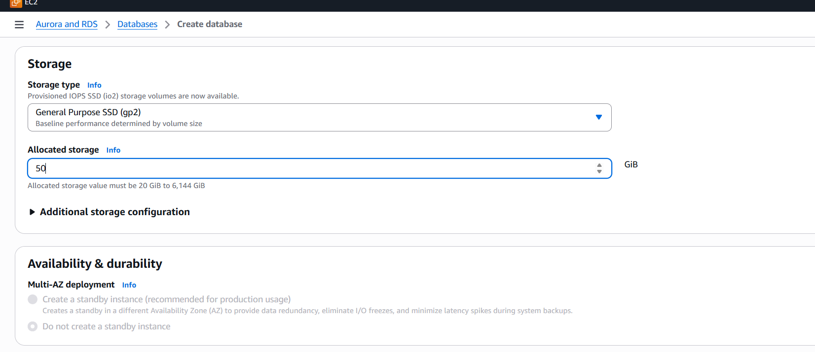
- Enable Auto-scaling (optional) → ( now we don’t need auto scaling ) adjusts storage automatically
Connectivity
- Virtual Private Cloud (VPC): Choose default or custom
- Subnet group: Default
- Public access: now I don’t want if you want to connect from outside AWS (EC2/local machine)
  - Default → Only accessible from inside VPC
- VPC security group: Create new → allow inbound port 3306 (MariaDB)
- Availability zone: Optional → choose one az

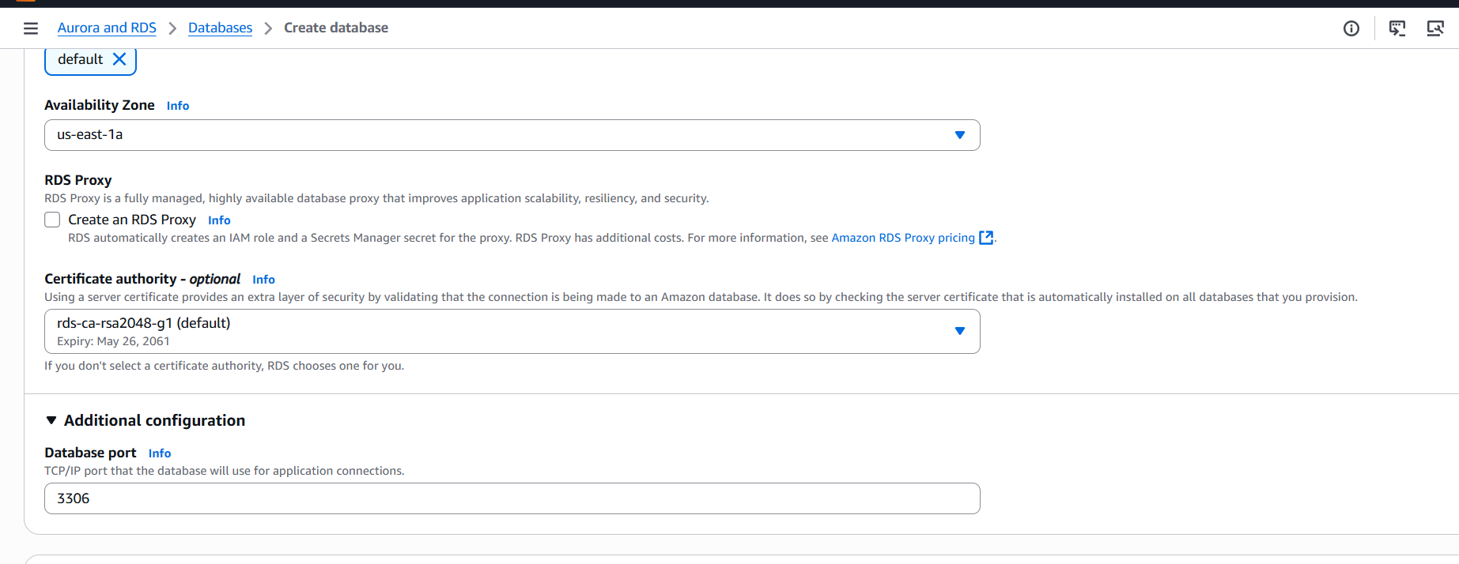
Choice default one
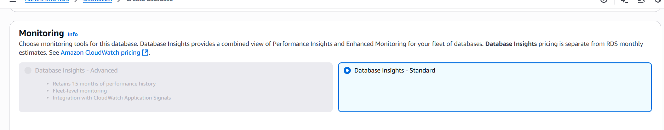

: Additional configuration
- Initial database name: mydatabase (optional, can leave blank)
- Enable automatic backups (recommended). In this case, I disable the auto back, I don’t want it right now
- Backup retention: 7 days default
- Encryption: Optional, enable if needed
- Maintenance settings: optional

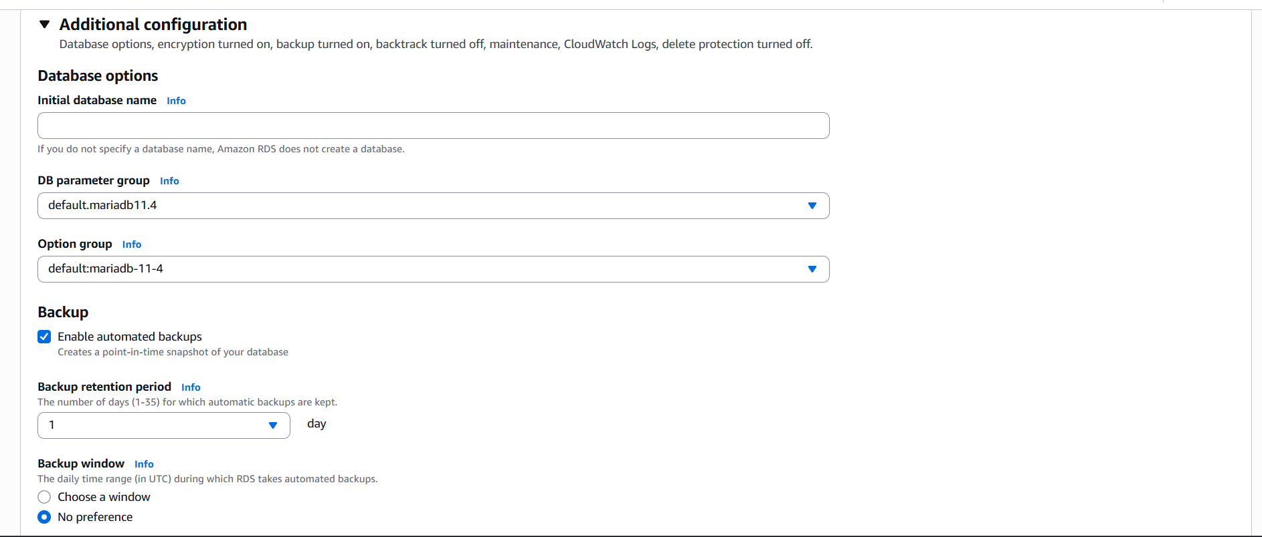
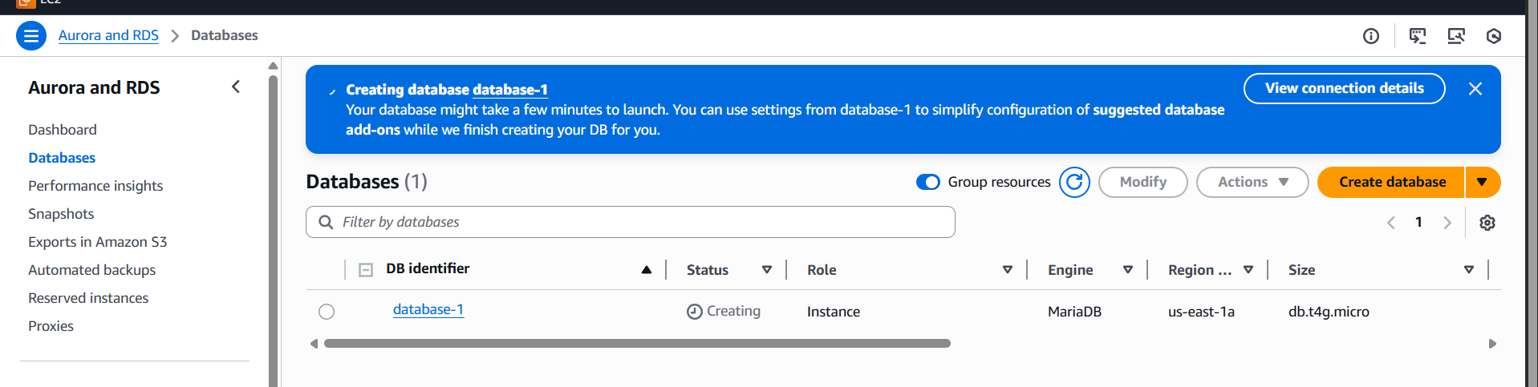
Review & Create
- Check all settings
- Click Create database
- RDS instance will now launch (status will show Creating)
- Wait 5–10 minutes until the status changes to Available
Configure the Security Group for access
- Go to EC2 → Security Groups used by RDS
- Add Inbound rule:
  - Type: MySQL/Aurora
  - Port: 3306
  - Source:
    - For testing → 0.0.0.0/0 (all IPs)
    - For secure → your IP only, e.g., 203.0.113.25/32
Connect to the MariaDB RDS instance
- Get Endpoint from RDS console (looks like mariadb-instance1.abcd1234.us-east-1.rds.amazonaws.com)
- Use MySQL client (from EC2 or local):
mysql -h <RDS_ENDPOINT> -P 3306 -u admin -p
- Enter the password you set during creation.
- Test commands:
SHOW DATABASES;
CREATE DATABASE testdb;
USE testdb;
CREATE TABLE employees(id INT AUTO_INCREMENT PRIMARY KEY, name VARCHAR(50));
INSERT INTO employees(name) VALUES ('Bharath');
SELECT * FROM employees;
Optional — Backup & Maintenance
- RDS automatically supports snapshots → manual backup is optional
- Enable automatic backups and multi-AZ deployment for production
- You can take manual snapshots anytime

Summary Table
Step | Action
1 | AWS Console → RDS → Create Database
2 | Engine → MariaDB, Version, Template
3 | DB Instance identifier, username, password
4 | Storage configuration (SSD, size)
5 | Connectivity → VPC, Public access, Security group
6 | Additional config → backup, encryption, maintenance
7 | Review → Create
8 | Security group → open port 3306 for your IP
9 | Connect using MySQL client
10 | Optional: Backup, snapshots, maintenance

- Migrate the database from EC2 to RDS.
We need to follow thses steps
AWS RDS Masterclass Commands
===========================
Databases on EC2 Instance - Demo
Begin Configuration :

sudo su -
yum -y install mariadb-server wget
systemctl enable mariadb
systemctl start mariadb
yum -y update

Set Environmental Variables
========================
DBName=ec2db
DBPassword=admin123456
DBRootPassword=admin123456
DBUser=ec2dbuser

Database Setup on EC2 Instance:
=============================
echo "CREATE DATABASE ${DBName};" >> /tmp/db.setup
echo "CREATE USER '${DBUser}' IDENTIFIED BY '${DBPassword}';" >> /tmp/db.setup
echo "GRANT ALL PRIVILEGES ON *.* TO '${DBUser}'@'%';" >> /tmp/db.setup
echo "FLUSH PRIVILEGES;" >> /tmp/db.setup
mysqladmin -u root password "${DBRootPassword}"
mysql -u root --password="${DBRootPassword}" < /tmp/db.setup
rm /tmp/db.setup

Adding some dummy data to the Database inside EC2 Instance:
==================================================
mysql -u root --password="${DBRootPassword}"
USE ec2db;
CREATE TABLE table1 (id INT, name VARCHAR(45));

INSERT INTO table1 VALUES(1, 'Virat'), (2, 'Sachin'), (3, 'Dhoni'), (4, 'ABD');

SELECT * FROM table1;

Migration of Database in EC2 Instance to RDS Database:

mysqldump -u root -p ec2db > ec2db.sql

mysql -h <replace-rds-end-point-here> -P 3306 -u rdsuser -p rdsdb < ec2db.sql
mysql -h <replace-rds-end-point-here> -P 3306 -u rdsuser -p
USE rdsdb
SELECT * FROM table1;

bharathi master paswd
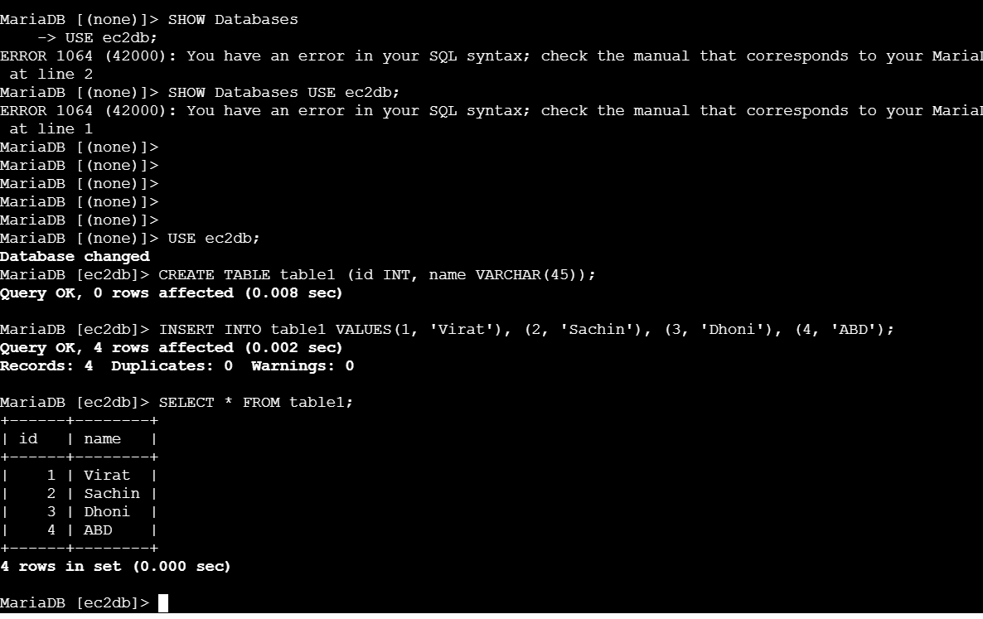

- Install MySQL DB on EC2.
Step 1: Launch one ec2
# install MySQL server
Step 1: Update the system
sudo apt update
install mysql
sudo wget https://dev.mysql.com/get/mysql80-community-release-el9-1.noarch.rpm
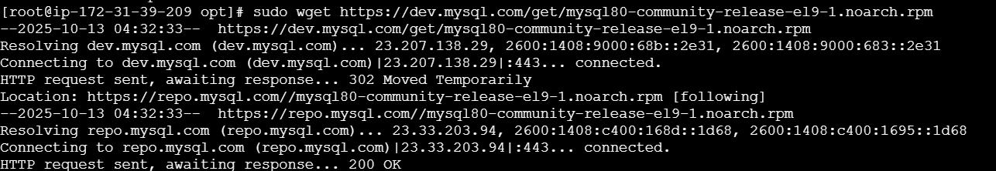
Verify the repo was added
sudo dnf install mysql80-community-release-el9-1.noarch.rpm -y
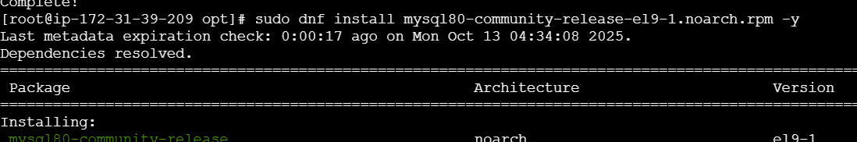
sudo dnf install mysql-community-server -y
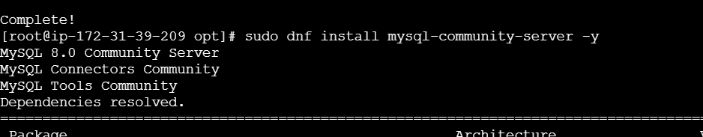

sudo systemctl start mysqld
sudo systemctl enable mysqld
sudo yum install -y mysql-community-server
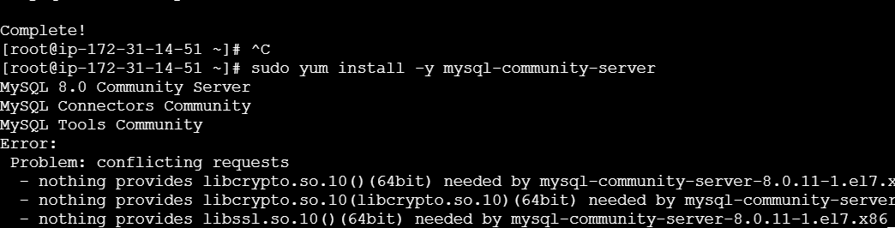
- Download the correct MySQL repo RPM:
wget https://repo.mysql.com/mysql80-community-release-el9-3.noarch.rpm
Check the MySQL site if this version doesn’t exist; you can always list the latest RPMs here:
MySQL Yum Repository
- Install the RPM to enable the repo:
sudo dnf install mysql80-community-release-el9-3.noarch.rpm
- Check enabled MySQL repos:
sudo dnf repolist enabled | grep mysql
- You should see mysql80-community in the list.
- Install MySQL server:
sudo dnf install mysql-community-server
sudo dnf install mysql-community-server -y
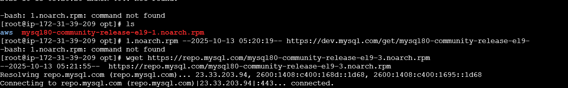
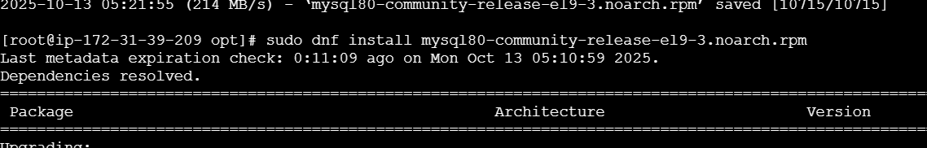
sudo dnf repolist enabled | grep mysql
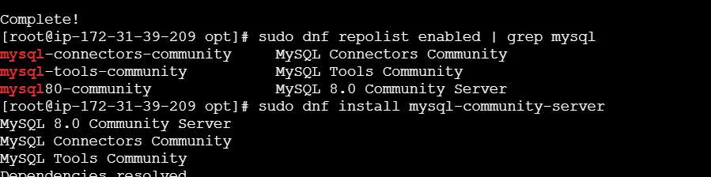
sudo systemctl start mysqld
sudo systemctl enable mysqld
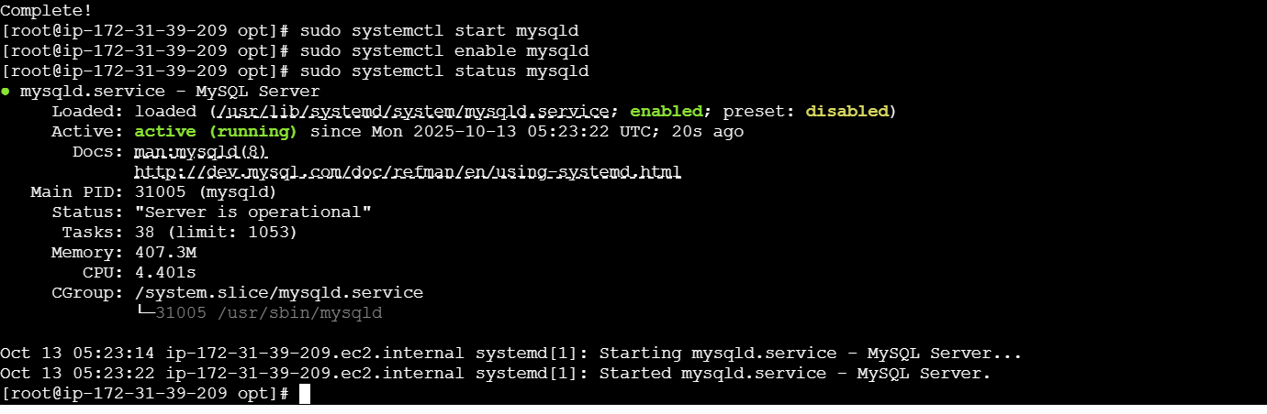

- Launch MySQL RDS image.
Step 1: Login to AWS, select Aurora and RDS◊Database◊create
database◊standard create◊ Mysq
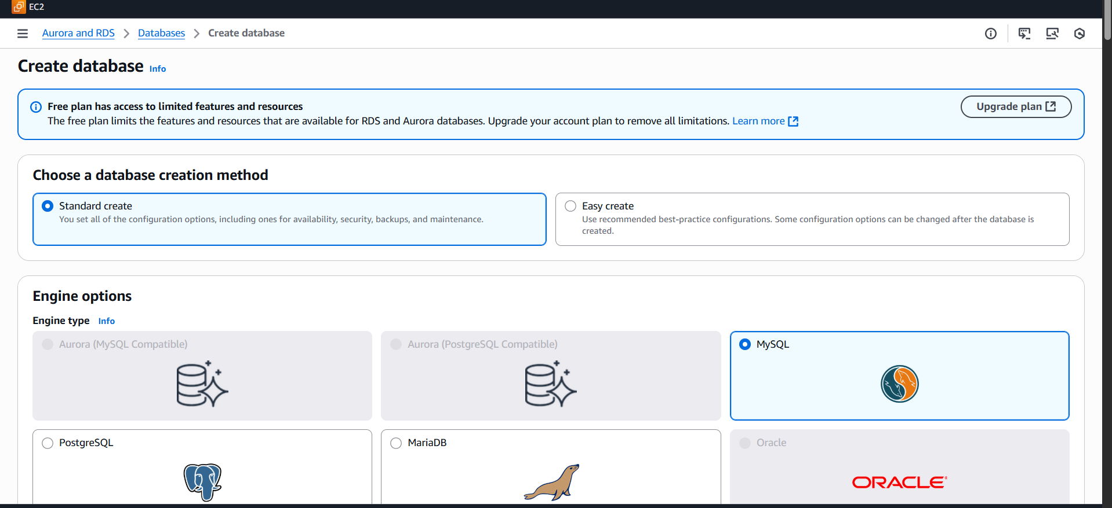
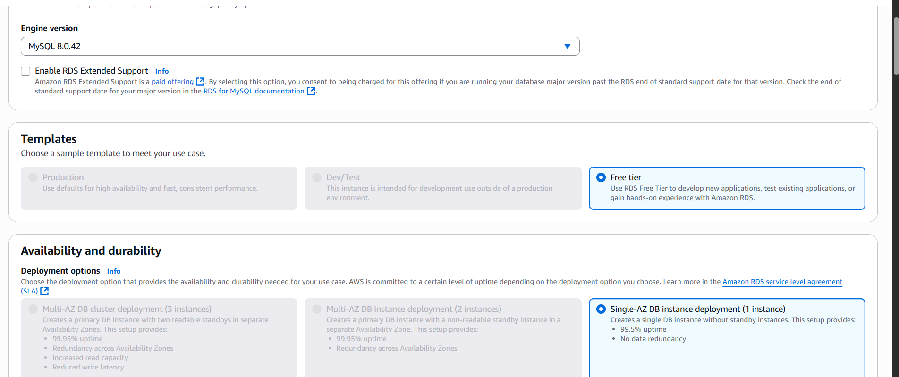
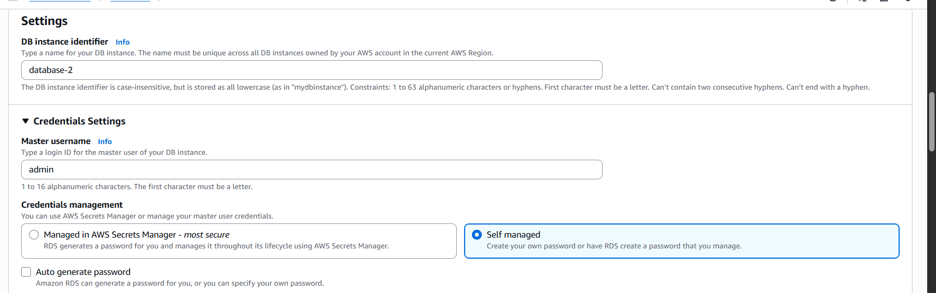
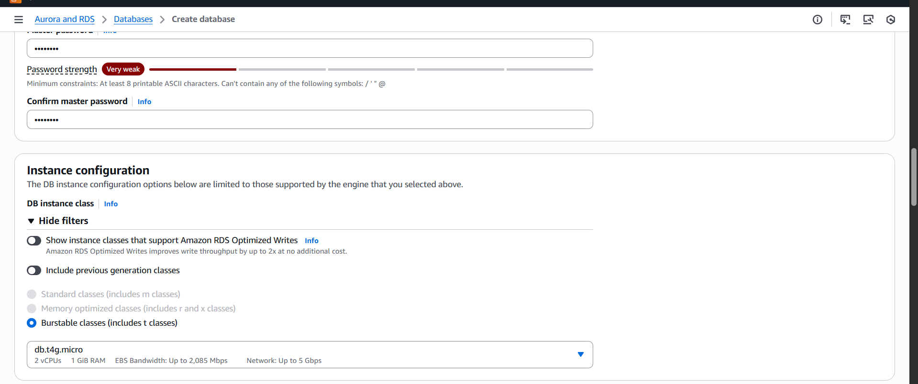
Step 3: select connectivity settings and click create.
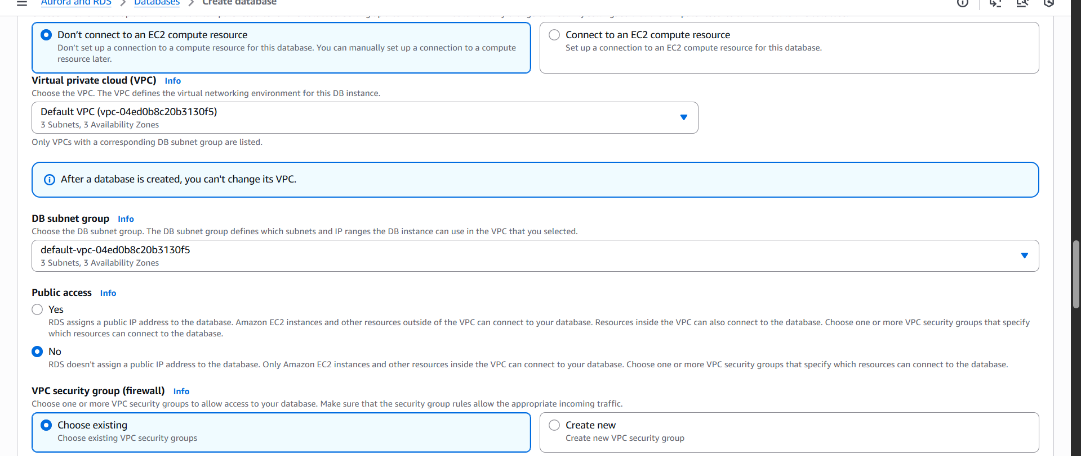

- Configure Multi-AZ
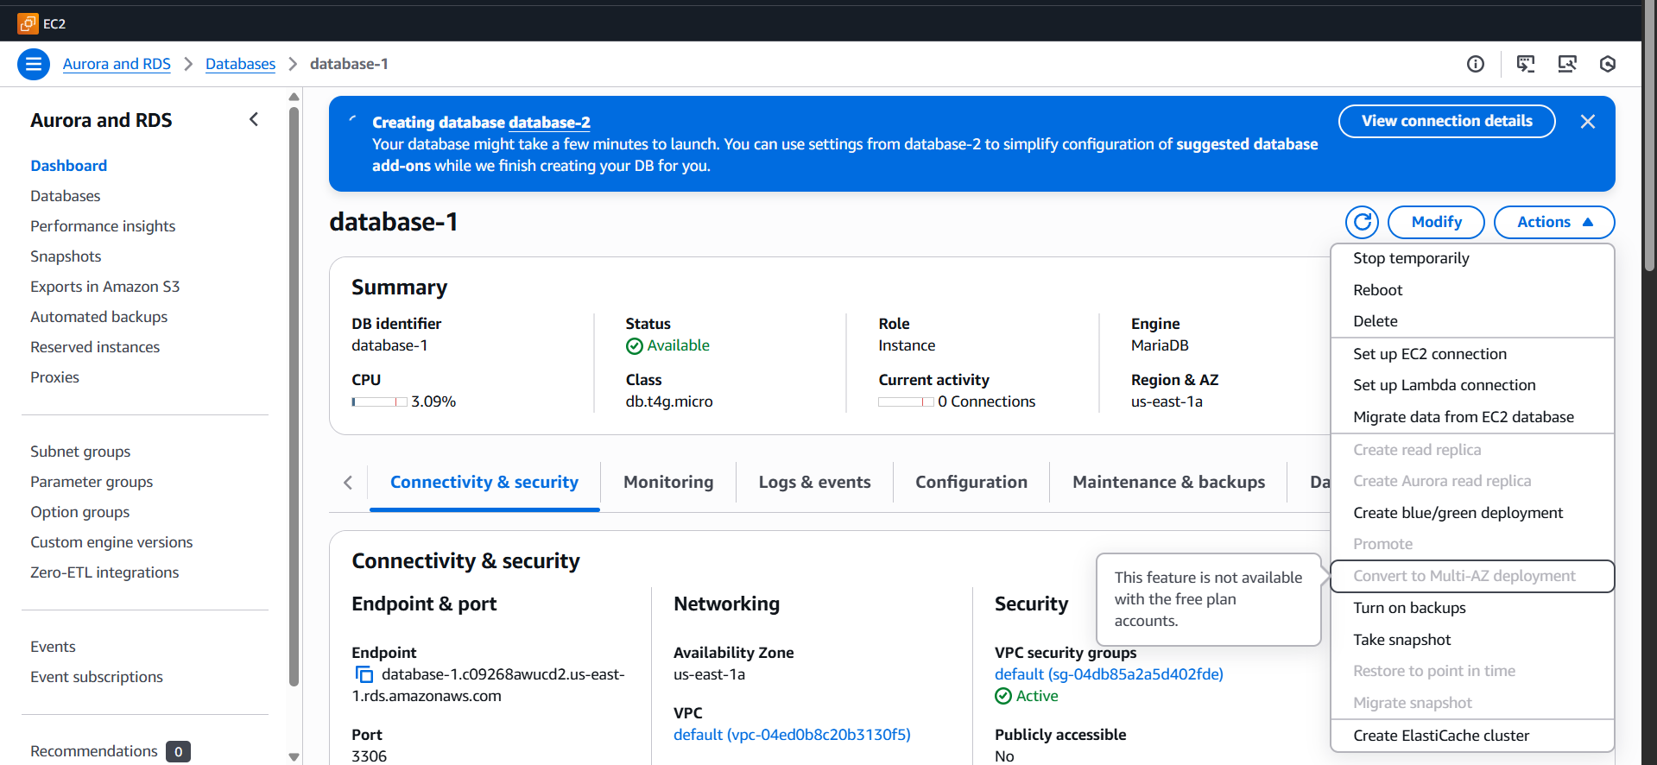

9 . Take a backup of the DB and restore the DB.

Go to the action and click on the snapshot

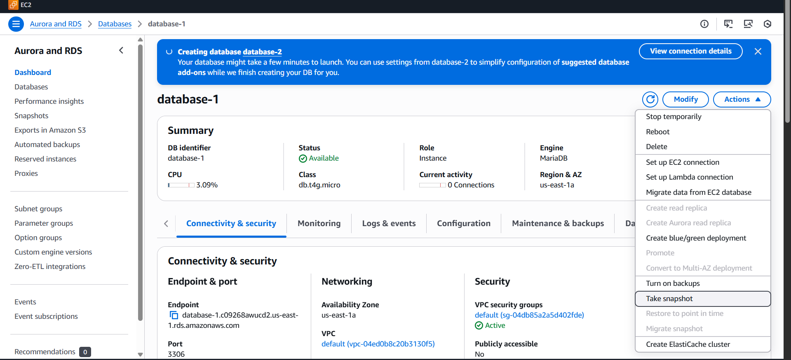
I took one snapshot
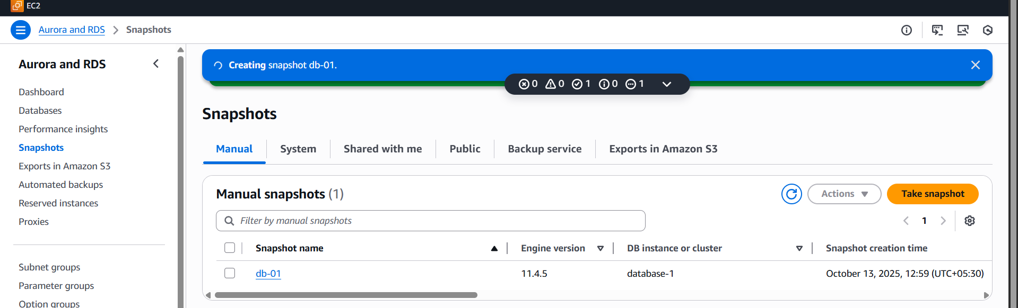
I deleted the database 1
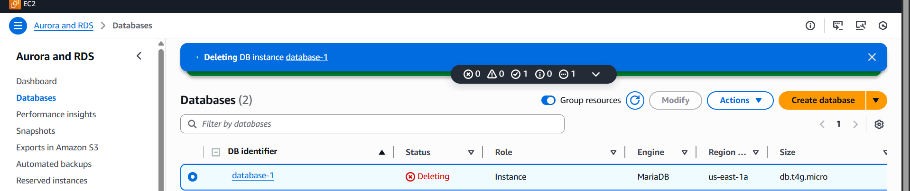
Go to the snapshot, click what you backed up
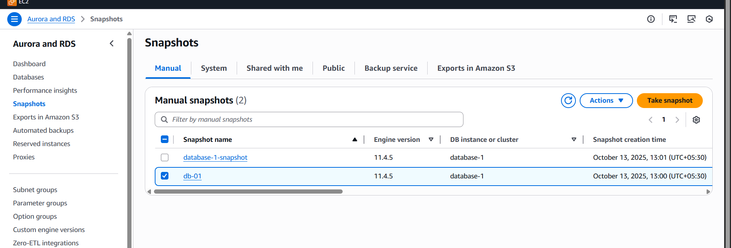
Goto RDS◊snapshots◊select your snapshot◊Actions◊restore
snapshot.
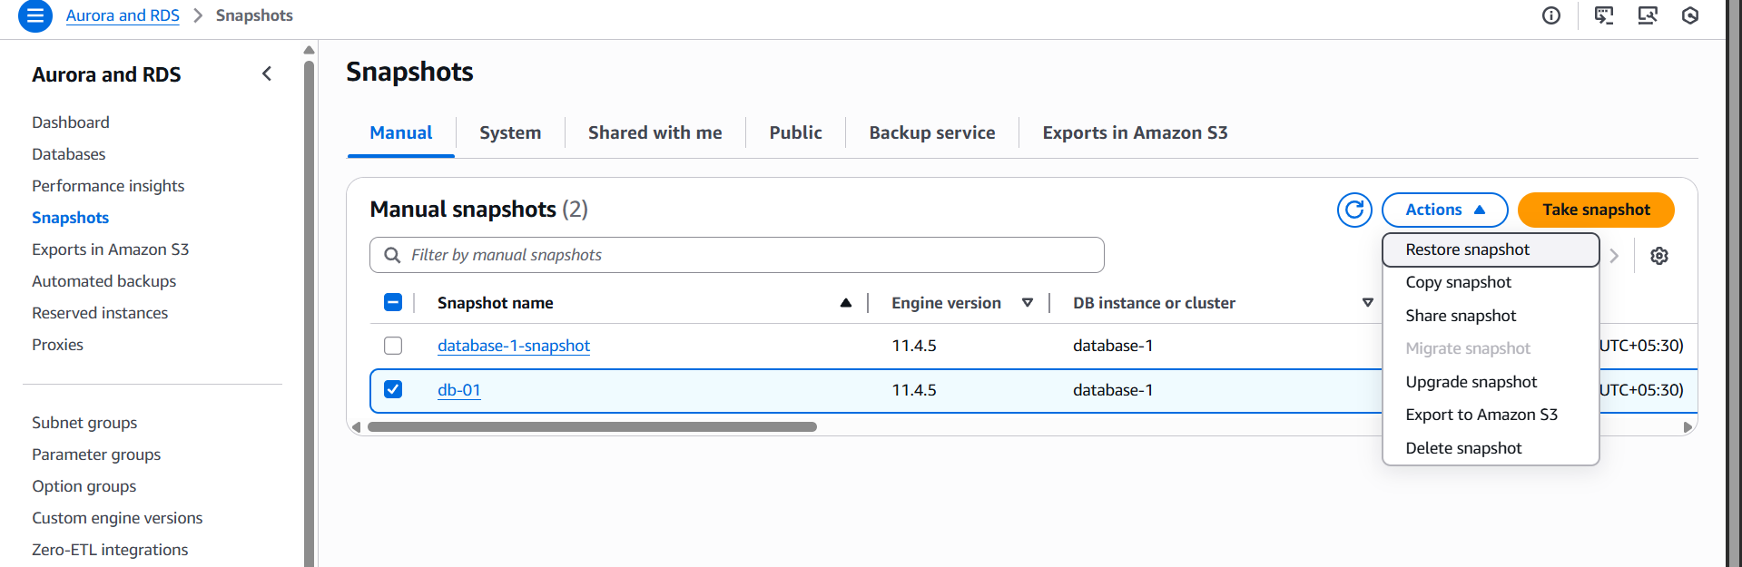
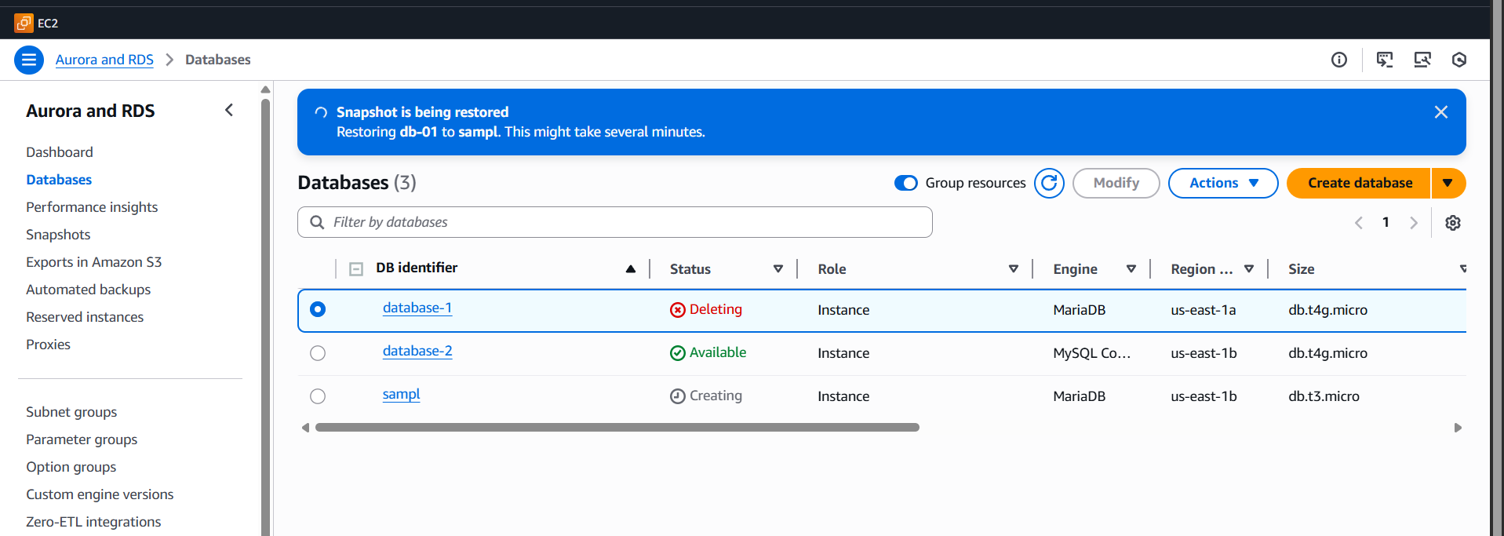
Successfully restore
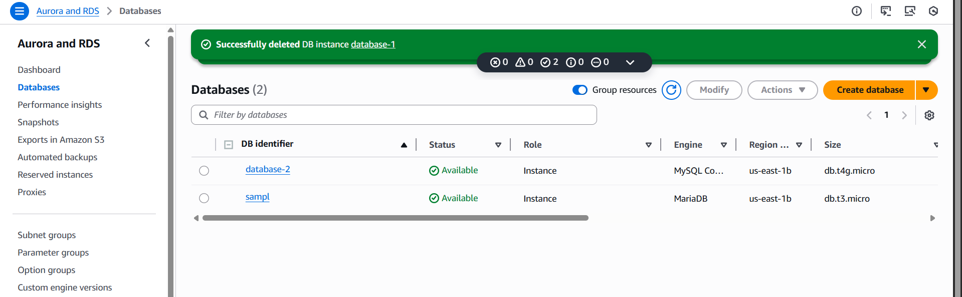

10 . Create read replica.
Create read replica.Step 1: Goto RDS Database,
select database Actions
create read replica
Create Read Replica
- Select your primary DB instance.
- Click Actions → Create read replica.
- Fill in the details:
  - DB Instance Identifier: Give a name for the replica (e.g., mydb-replica).
  - DB Instance Class: Choose based on your read workload.
  - Multi-AZ Deployment: Optional (for HA).
  - Public Accessibility: Optional, based on whether you want it accessible outside VPC.
  - VPC & Subnet: Choose the same VPC as primary.
- Optional Settings:
  - Enable Automatic Backups for the read replica.
  - Enable Encryption if required.
- Click Create read replica.

Step 4: Wait for Replica to be Available
- The read replica will show as creating.
- Once ready, the status will change to available

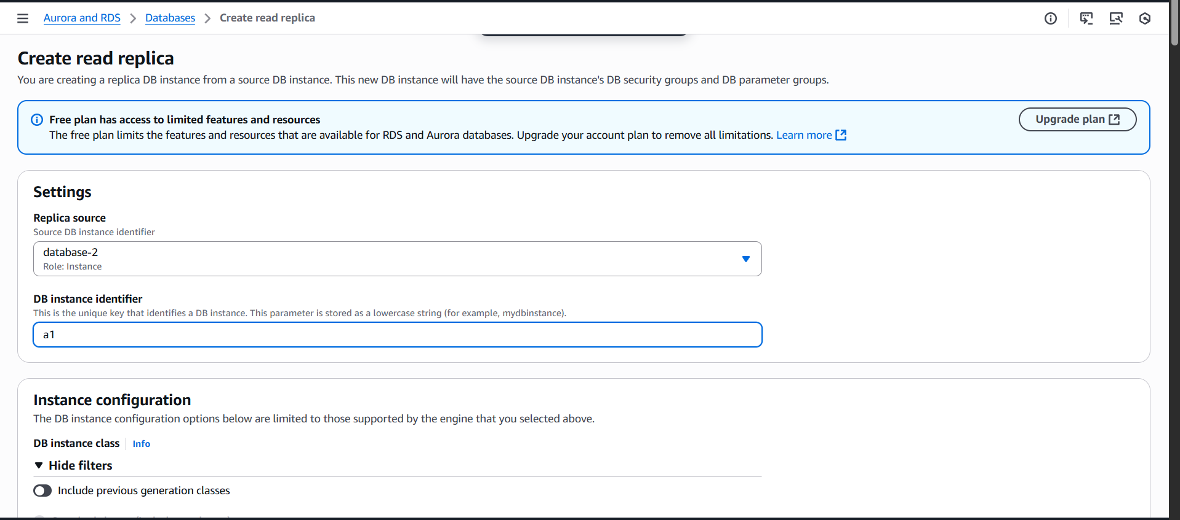
Give enough details
